Rensselaer Mechatronics

Lab 1.5 In-Class Exercise
Contents
Software Verification: 1
Part 1: Blinking LED example on Hardware: 6
Part 2: Motor example on Hardware, viewing data in a scope, plotting, and saving data. 8
Part 3: Voltage and Current Measurements with a multimeter 12
Part 4: Step Response Plotting 16
Part 5: Slow Ramp Response Test 17
Troubleshooting 18
Your username or MATLAB path has spaces or other symbols; “Error(s) encountered while building…” 18
Could not connect to target application: XCP serial port (system:2) 20
Could not connect to target application: XCP serial port timeout error on a MAC 20
Could not connect to target application: XCP serial port (system:22) 20
Hardware Tab Does not Show Up 20
Permission denied or Can Not access error when compiling 21

Software Verification:

- Open MATLAB 2024a. From the MATLAB window select “Add-Ons”, “Manage Add-Ons”, and click the gear icon for the Simulink Support Package for Arduino Hardware.
i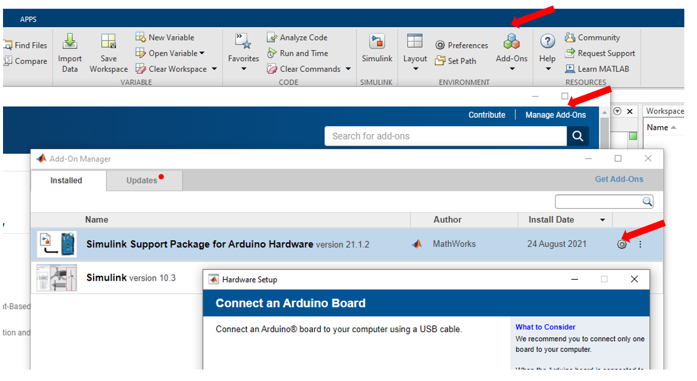
- Leave the default boards selected and select “Next” for the following 3 screens:
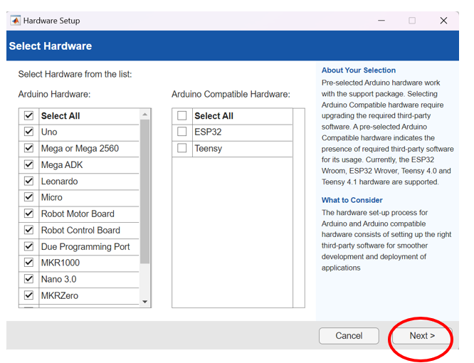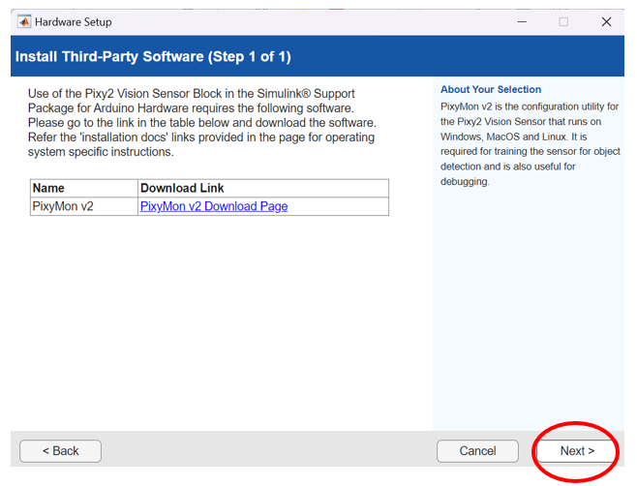
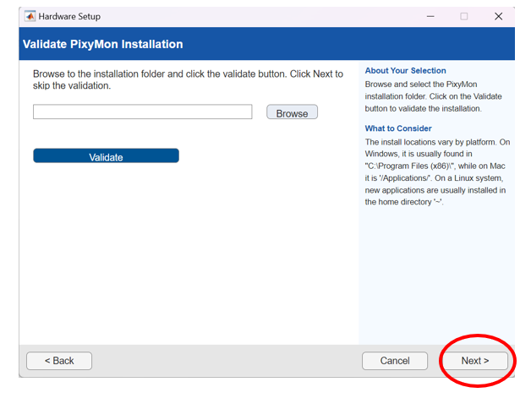

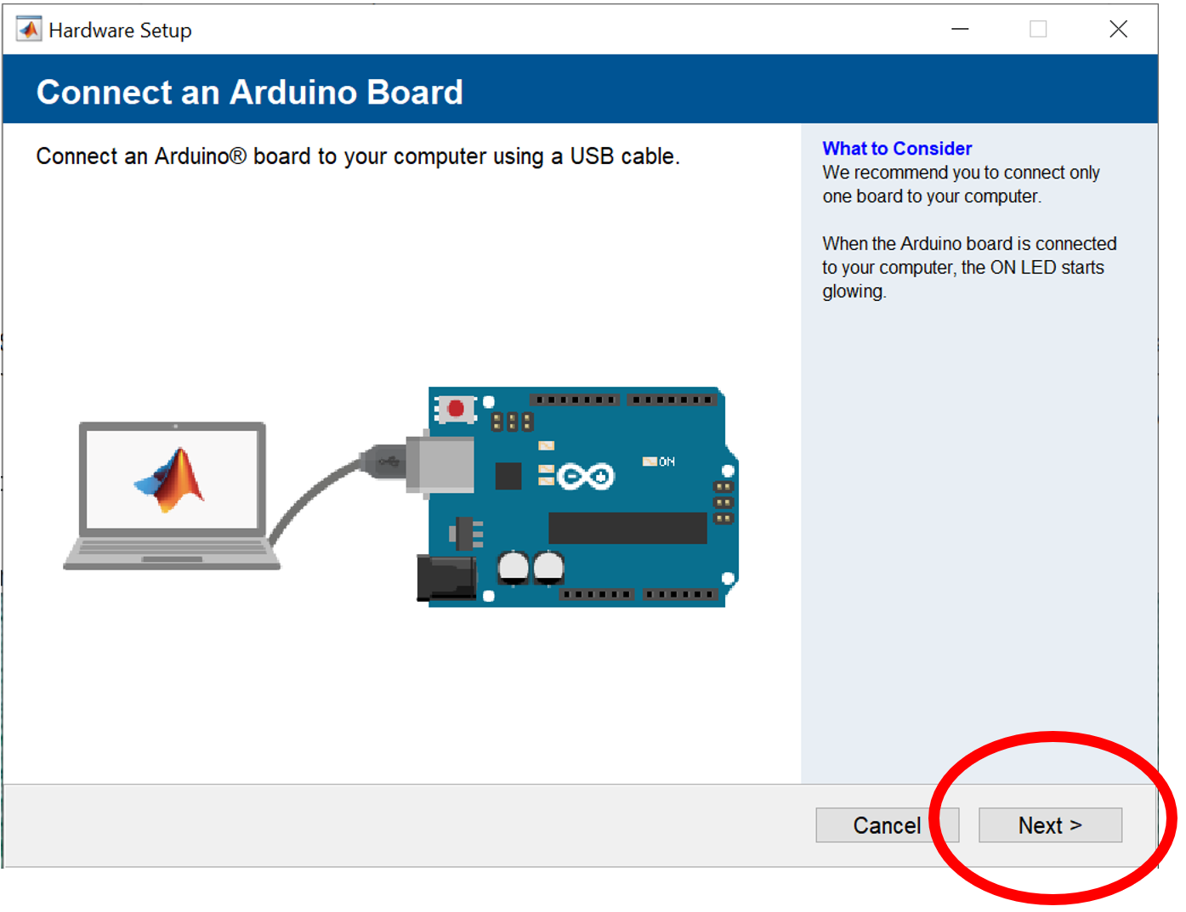
Make sure your board is plugged in and select Next. It will take a couple minutes before getting to the next screen. The next screen may automatically detect your board and show up as “Arduino Mega or Mega 2560” in which case you can select “Next”.
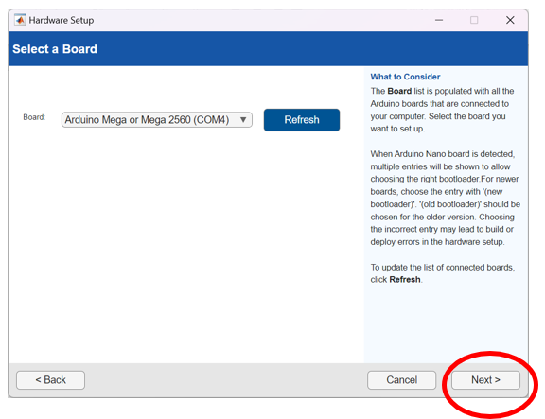
If it does not show up click “Arduino Drivers Installation” and follow the steps in that link. You will be looking for a USB Serial device or similar name when you follow the steps on that webpage.
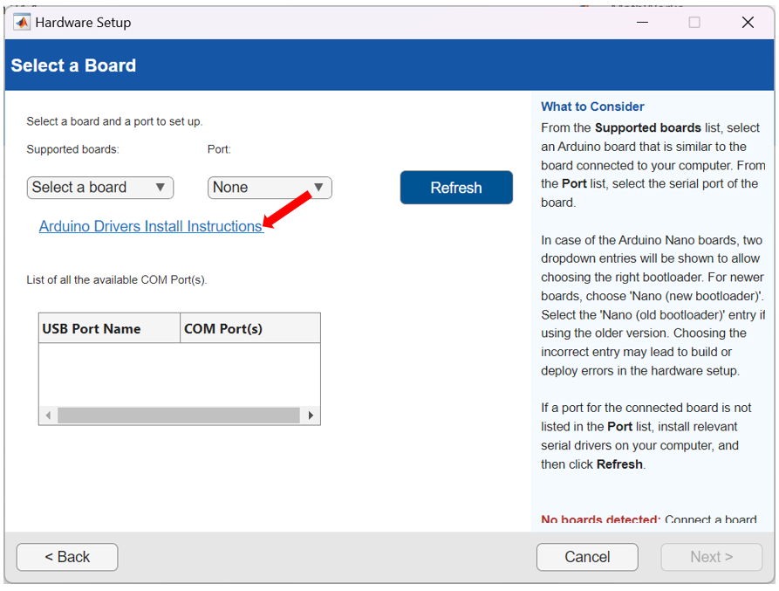

If it does not show up click “Refresh”, find the com port number that has “Serial Port (USB)”, then in the drop down menu select “Mega or Mega 2560” and “COM#” where the # is the number show in the “Serial Port (USB)” in the table.
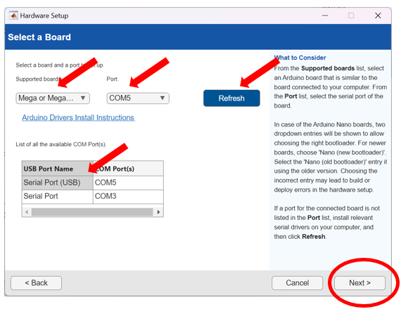

Click Next to verify the setup.

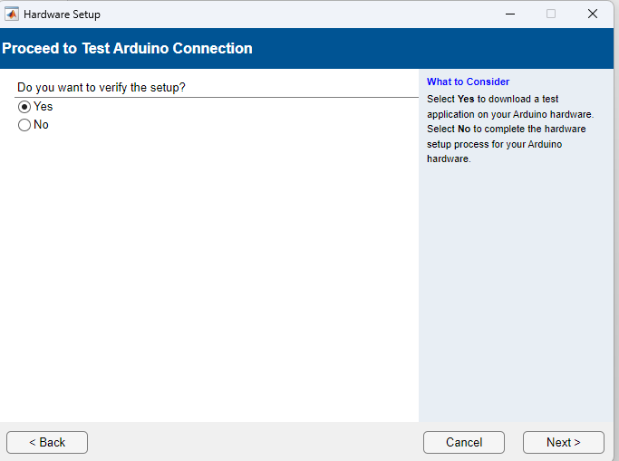

Allow the Java. Verify it builds and downloads:

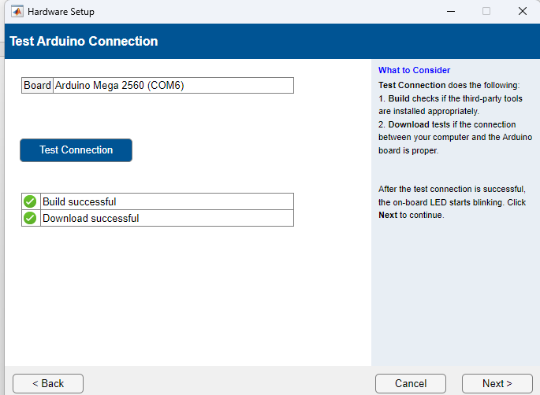

You are now ready to test your hardware using the steps below.

Part 1: Blinking LED example on Hardware:

- Plug the hardware into the USB port of your computer.
- Download test file "Test_File_1_LED_24a_R1.slx" from blackboard to your MATLAB folder (e.g. \Documents\MATLAB)
- Open MATLAB 2024a
- Navigate to the folder where the Simulink file is located:
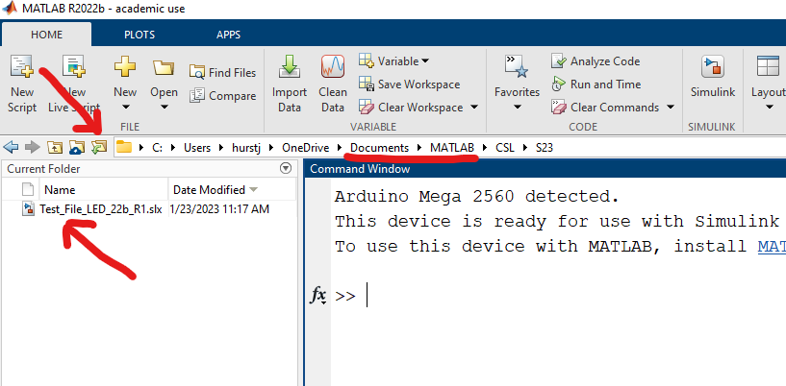
- Double Click to open the file to open the Simulink file.
- Click the Hardware tab, then press the green Monitor & Tune
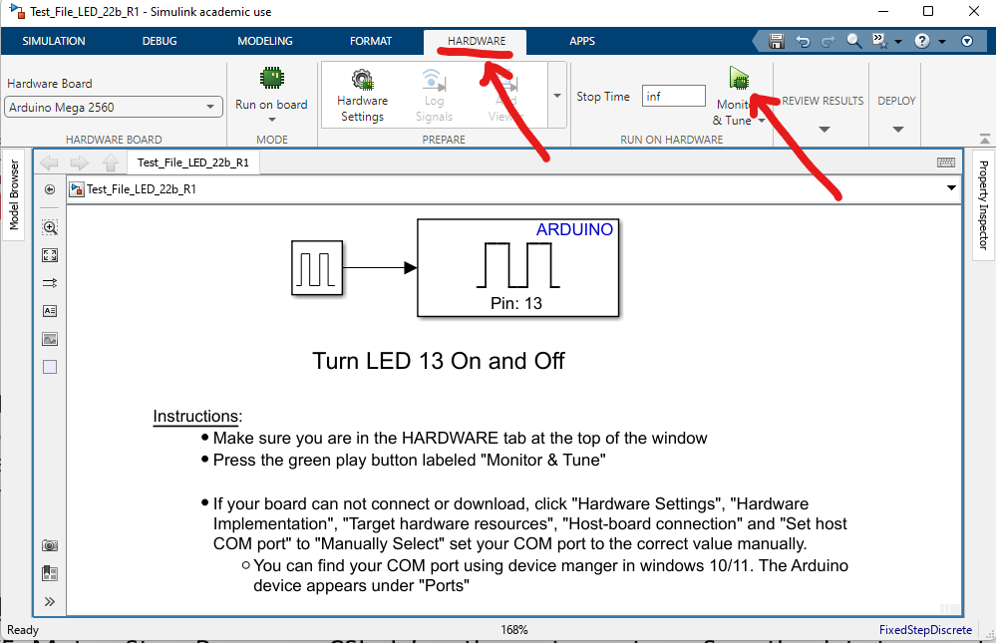
- Should take 1-2 minutes to compile and deploy, then one of the yellow LEDs (labeled "L") on the device will begin to blink every second (look through the hole in the top PCB).
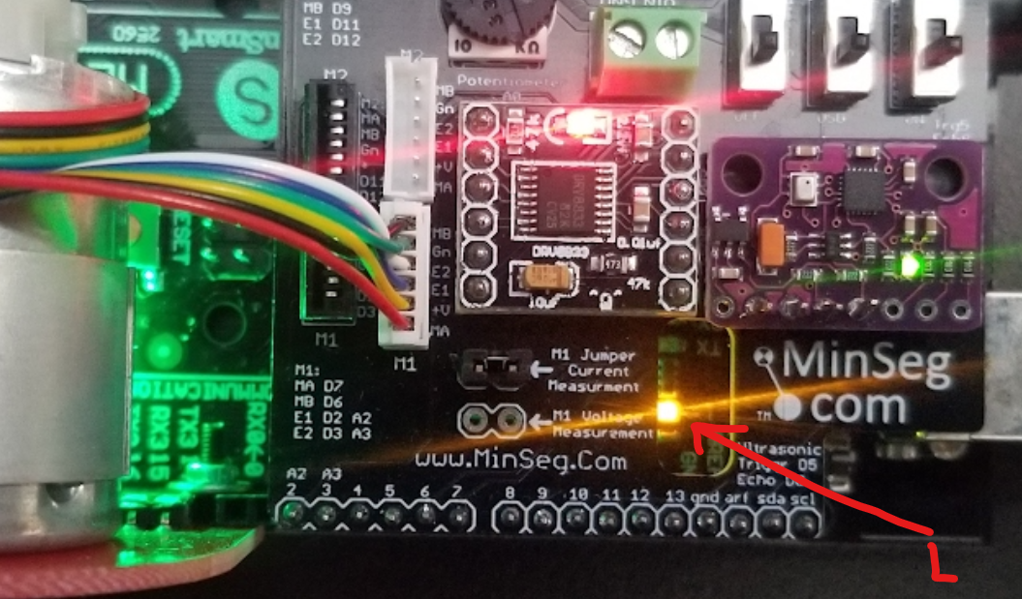
- Verify the experiment is running:
  - The file will indicate it is running on the bottom left of the diagram
  - The run time clock on the bottom right should be advancing in real time
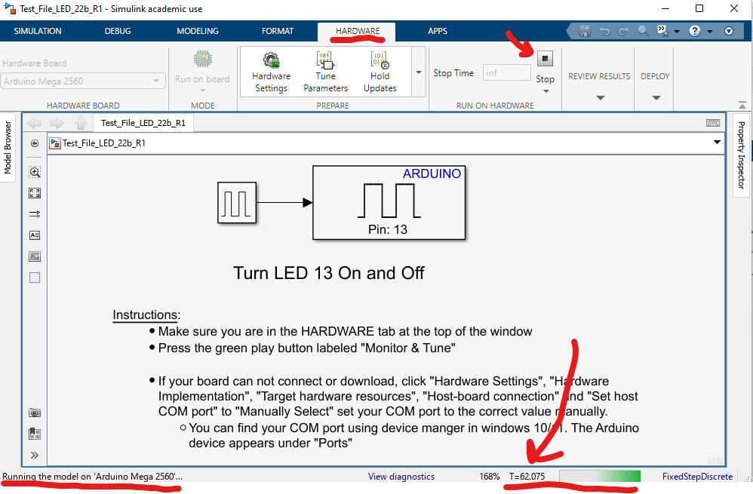
- Double click the pulse generator block and change the period to 0.1 seconds. The LED will blink faster now
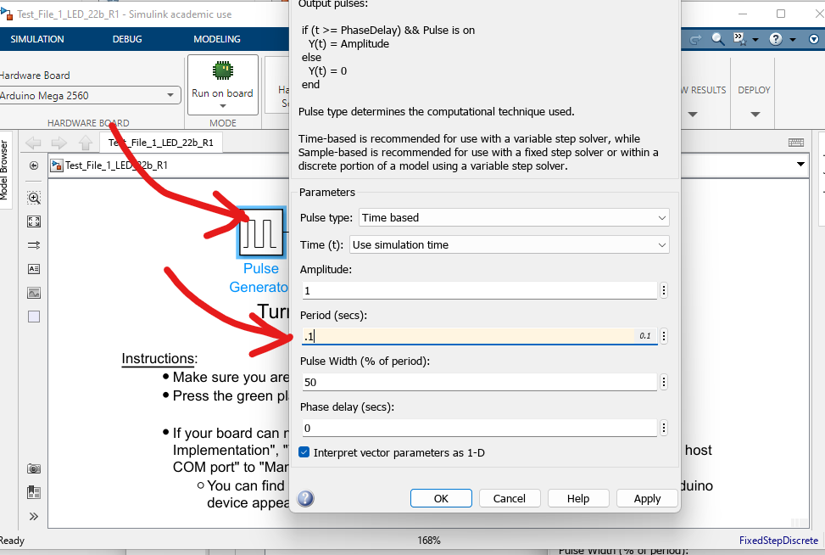
- You may stop the process at any time by pressing the stop button with the black square
- If it fails to run carefully read the red error messages and look for a similar error in the troubleshooting guide.

Part 2: Motor example on Hardware, viewing data in a scope, plotting, and saving data.

Q2.1 Motor ID: The DC motor system is labeled with a number. Please make note of this identifier in Gradescope.

- Download test file " Test_File_2_Motor_Test_24a_R1.slx" from blackboard to your MATLAB folder (e.g., \Documents\MATLAB)
- Navigate to the folder where the Simulink file is located and open the file.
- Click the Hardware tab, then press the green Monitor & Tune
  - After 1-2 minutes the code should start running and the motor should start spinning.
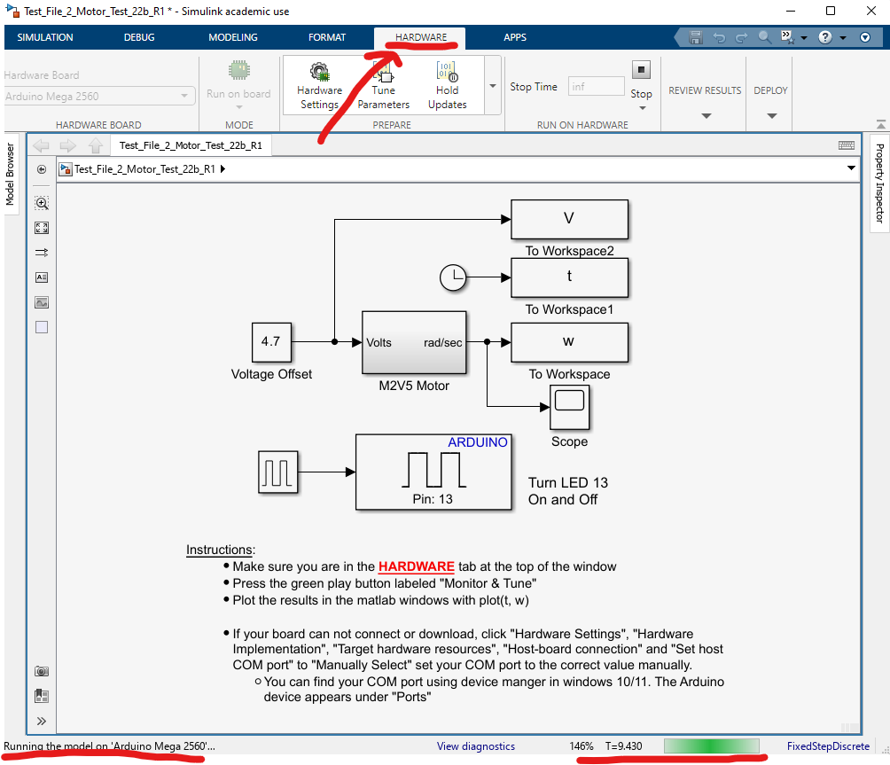
  - While the code is running data is being written to the variables V, t, and w, however data is NOT available until you stop the code.
- While the code is running double click the Scope. Move and resize the windows so you can see your Simulink diagram and the scope at the same time
. 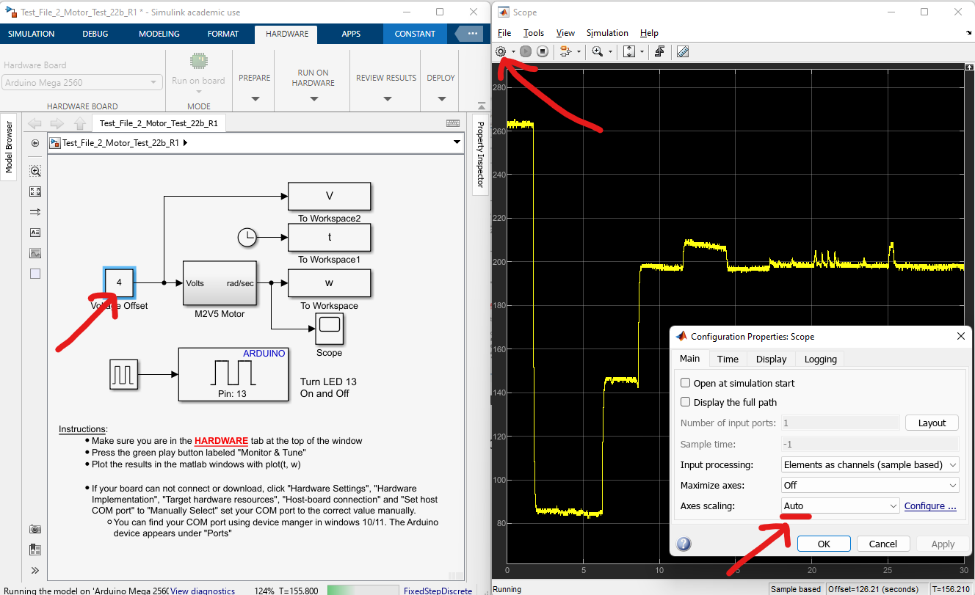
  - Change the Voltage Offset to 3 volts and observe the change in the scope. Next try 1.5 volts. You should see the motor change speed as you modify the voltage that is applied to the motor.
  - Click on the gear icon at the top left of the scope window. Notice that axes scaling is set to “auto” so that the y-axis limits will change as the data changes
  - Notice in this case the y-axis limits were scaled to 0 to 280 radians per second.
  - In the Scope Configuration Properties window click the time tab.
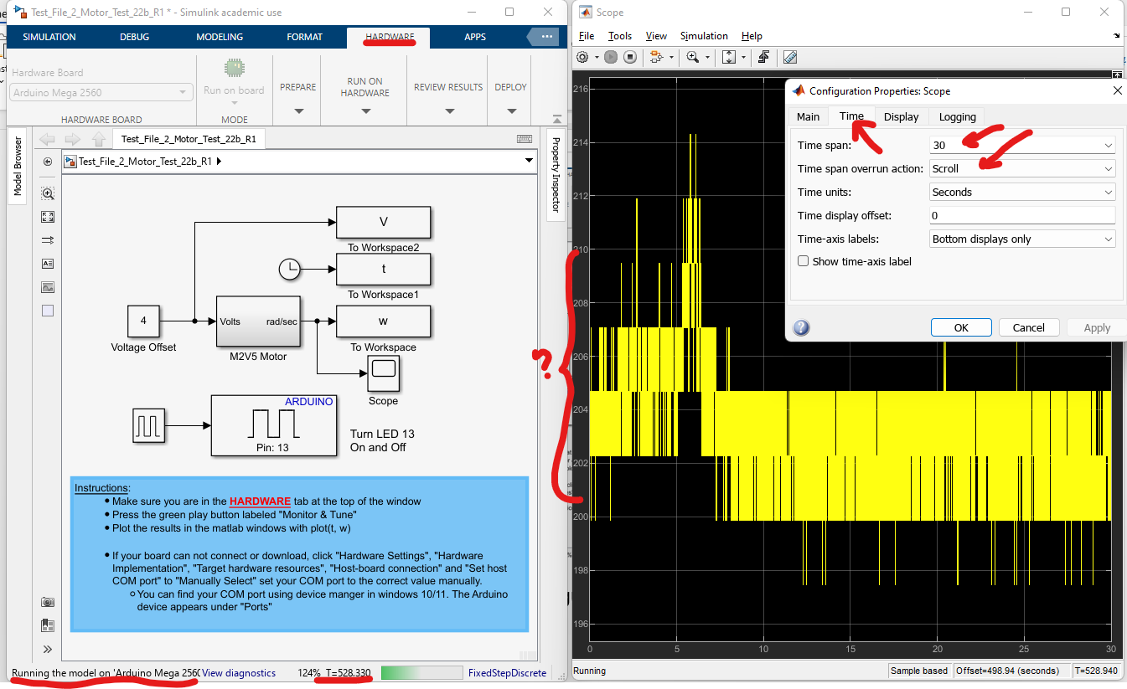
  - Notice that the x-axis limit is set to 30, and the data is set to scroll across the screen.
  - In future labs it may be desirable to modify the scope settings based on the experiment you are performing, and the scopes may have different default settings.
  - Notice in this screenshot the data looks very noisy, this is because it has auto scaled to have the y-axis zoomed in to 200 to 210 rad/sec - zoomed in this far it will look noisy. Always be careful interpreting data when using auto-scale.
  - You can set the scaling to manual in the main settings tab, then use the autoscale button at the top:
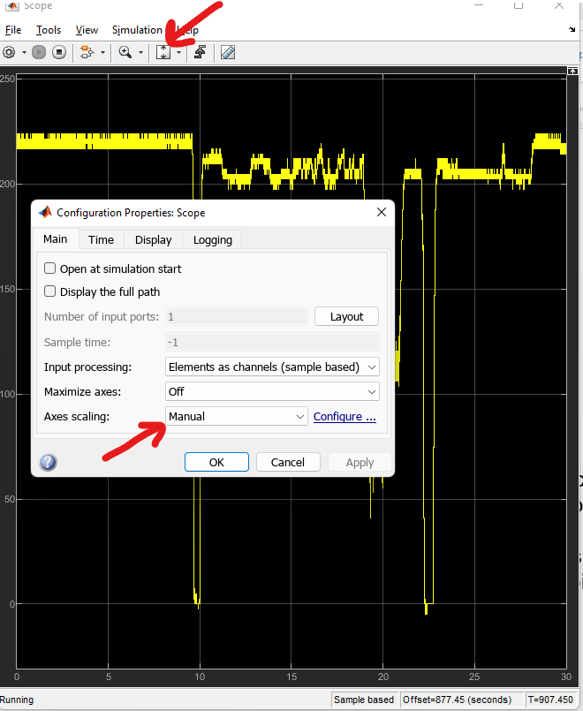
  - You can manually specify the x-axis limits in the Display tab:
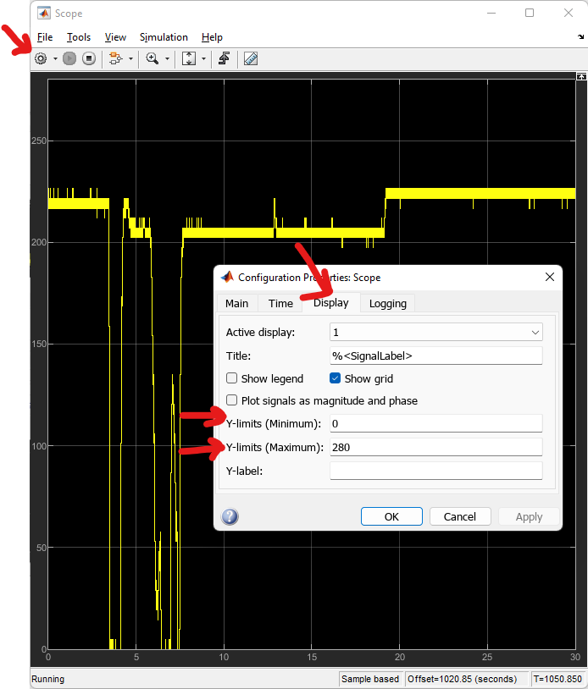

- Once you are comfortable with the scope settings click the stop button in your Simulink diagram.
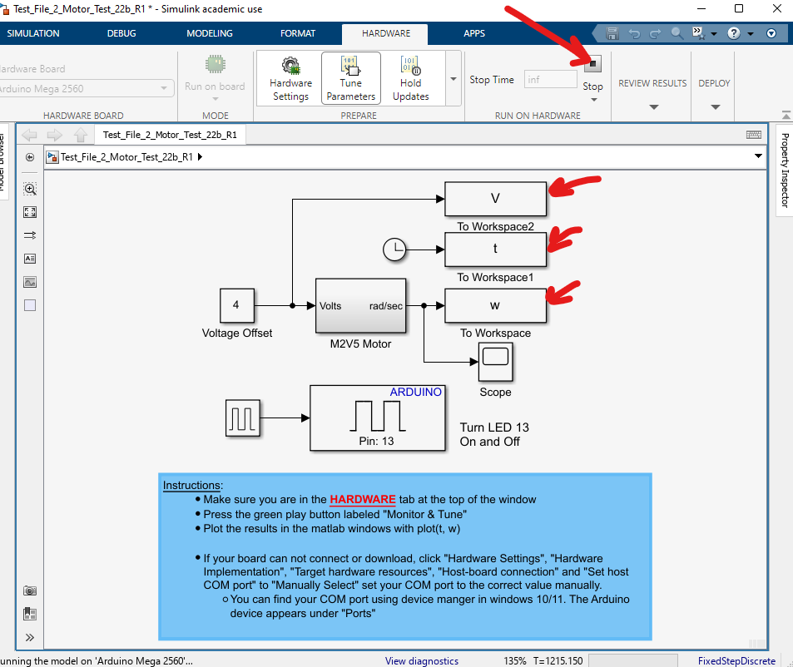
  - In the Matlab workspace the data for the experiment has been stored in the variables V, t, w, and you can plot the speed vs. time with plot(t,w).
  - If you get a spurious data point as seen in this figure you can ignore it.

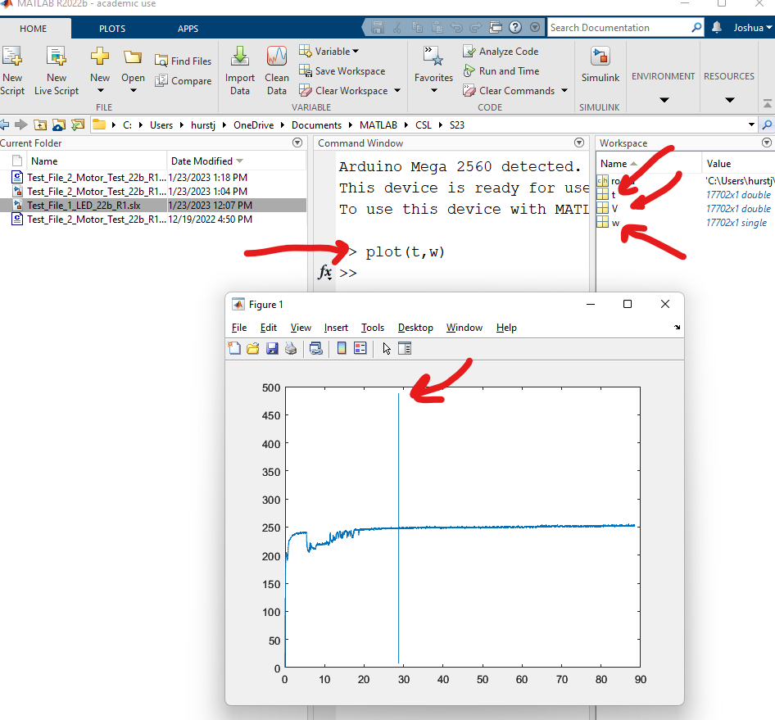
  - Save the data by control or shift clicking the variables to select all of them, then right clicking, Save-As. The data will be stored in the .mat file
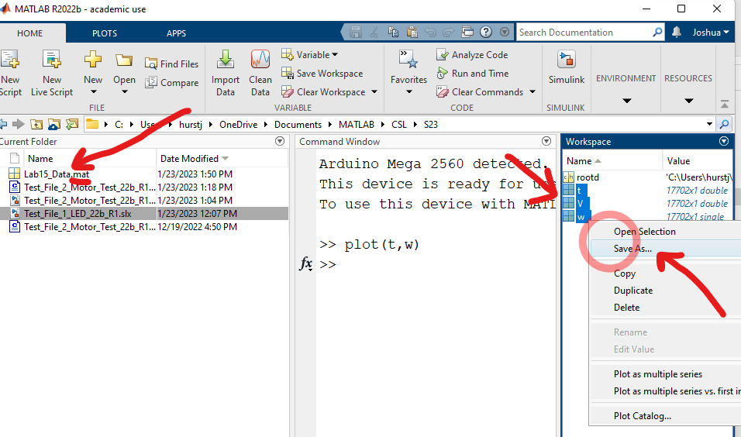
  - Then the data can be loaded and plotted later:
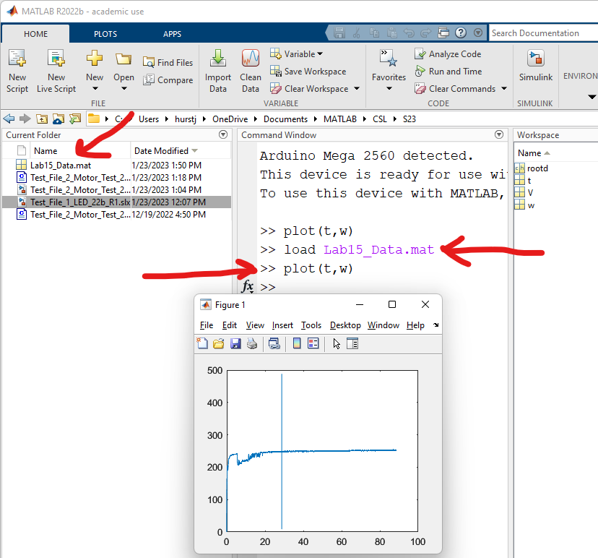
  - Try saving and plotting the data. To test this type “clear all” in the Matlab command window. This will clear all the variables. Then try loading and plotting the data from the saved file.
- Be sure you are comfortable with the scope settings, running experiments, saving, loading, and plotting data before moving on to the next section.

Part 3: Voltage and Current Measurements with a multimeter

3.1 Multimeter ID: The Multimeter is labeled with a number. Please make note of this identifier in Gradescope
Do NOT pull the multimeter leads by the wires, pull them by the Plastic and if you need to twist them clockwise (if you twist counterclockwise the plastic will unscrew):
Be very careful measuring current – if you blow a fuse you will have to replace it during class!
3.2 Free Spinning Voltage
- Configure the multimeter for voltage measurement:
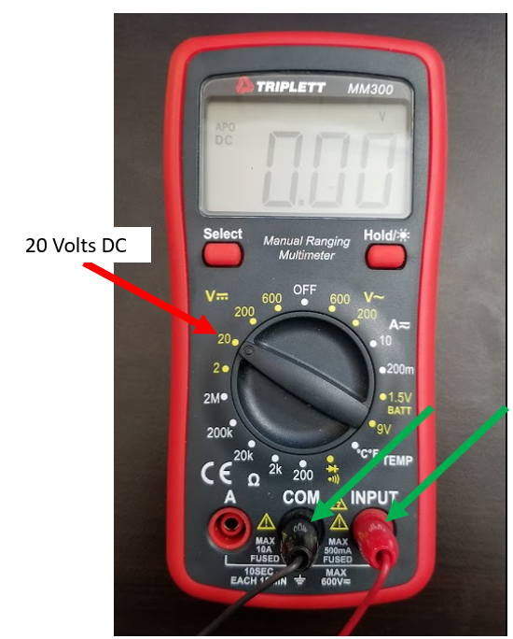
The hardware uses USB voltage from your computer which is nominally 5 volts. The appropriate setting of the multimeter is 20 volts (0-20).

- The two ends of the multimeter leads should be attached to the Arduino board as shown:
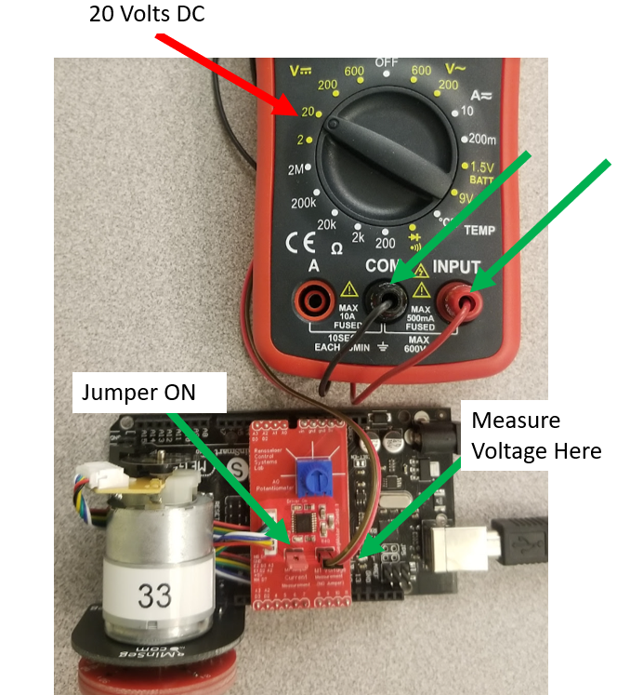
Note the small text on the PCB indicates which pins are used to measure current and voltage. The current pins must have a jumper attached or the motor will not spin.
- Run the test file " Test_File_2_Motor_Test_24a_R1.slx" with a voltage of 1.5 volts specified in the Voltage Offset block, then observe and record the measured voltage applied to the motor. Record the. Enter this voltage in Gradescope.

3.3 Free Spinning Current

- Configure the multimeter for current measurement. Current set to 10 amps, black wire in COM, and red wire on the left connector with the “A” which is used for the 10A setting:

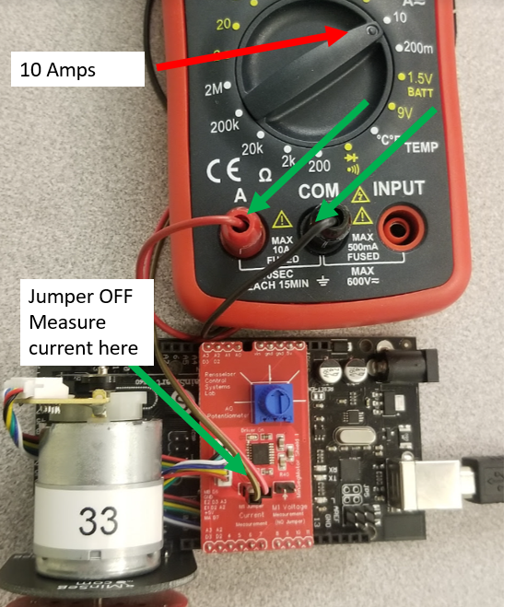

- Remove the jumper where it says “M1 Jumper current measurement” on the Arduino board. This is equivalent of cutting one of the motor wires. Attach the multimeter leads on the board as shown below:

Attaching the leads now passes all the current in the motor wire through the multimeter.
- Run the test file " Test_File_2_Motor_Test_24a_R1.slx" with a voltage of 1.5 volts specified in the Voltage Offset block, then observe and record the measured current applied to the motor. Record the. Enter this current in Gradescope.

3.4, 3.5 Stalled (zero speed) Voltage and Current Measurements
The motor disk will be held stationery and voltage and current will be measured. When the motor is not moving (zero speed), the current is just flowing through the motor wire – no other physics are occurring and V=IR. If the estimated motor resistance is 8.5 ohms. The applied voltage is 1.5 volts. The resulting current will be I = V/R = 0.1875A. This is below the 10 amps and the previous multimeter settings can be used to measure voltage and current. NOTE: if your experiment ever draws more than 10A the fuse in the multimeter will blow and you will have to replace it during class! It is crucial before any experiment to know your experimental conditions!
- Run the motor at a constant 1.5 volts, then hold the motor disk to keep it from spinning:
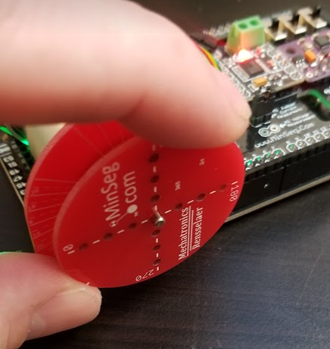
- Record the zero-speed voltage and current applied to the motor and record these values in Gradescope.

Part 4: Step Response Plotting
- Run the test file " Test_File_2_Motor_Test_24a_R1.slx" with a voltage of 1.5 volts specified in the Voltage Offset block. While the experiment is running change the voltage from 1.5 volts to 3.5 volts. Stop the experiment. Then plot the data to obtain the step response of the motor (plot speed vs. time). Be sure to zoom to get a nice mod con type step response. Be sure to label the axes and annotate the title with your name. Upload a screenshot of the step response. Please zoom in on your graph so it has the shape of one single mod con style step response which should look similar to the graph below:
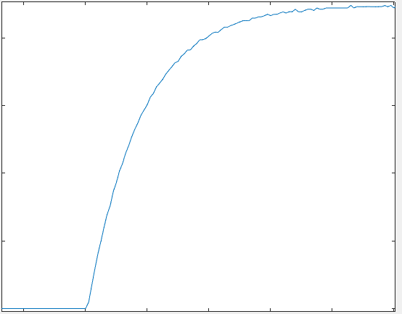
To zoom in on this part move your mouse to the upper right of the graph and hover to see a microscope with a “+” then select the rectangular area to zoom in:
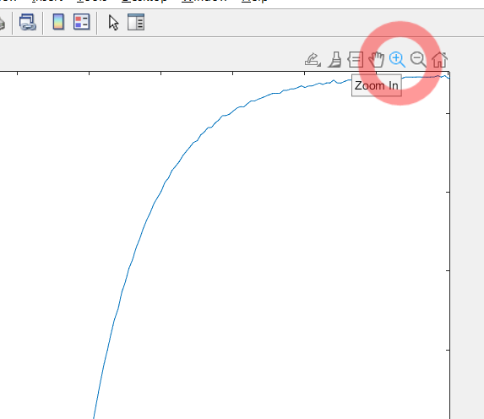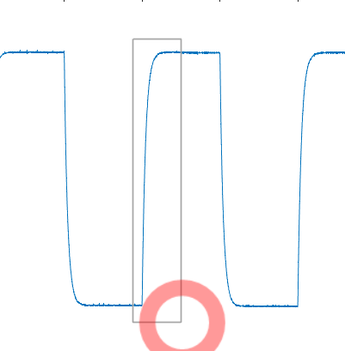

Part 5: Slow Ramp Response Test
- Open and the test file " Test_File_3_Ramp_Response_24a.slx". This experiment will slowly increase the voltage applied to the motor for 50 seconds. After the experiment stops, save and plot speed vs voltage from the data. Upload the saved .mat file to Gradescope and upload a screenshot of the ramp response.
  - plot(V,w). It should look similar to the following (but properly annotated and labeled):
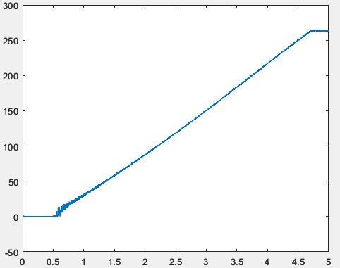

Troubleshooting

Your username or MATLAB path has spaces or other symbols; “Error(s) encountered while building…”

If you receive an error message “Error(s) encountered while building…”
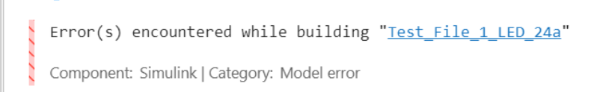
Scroll all the way to the top of the error message and see if the message is about not being able to resolve spaces in the username, or part of the path in the compilation have “????”.
If you get a compile error or directory not found make sure MATLABs working directory, and the folders and file names of the Simulink diagrams do not have spaces in them, there may be a space in your username. If so, you will need to move your folders to a location that does not have spaces. One possible way to handle this is as follows:
- Create a folder MyMATLAB on the C: drive (or some place with no spaces in it). Also create a compile folder inside of that folder:
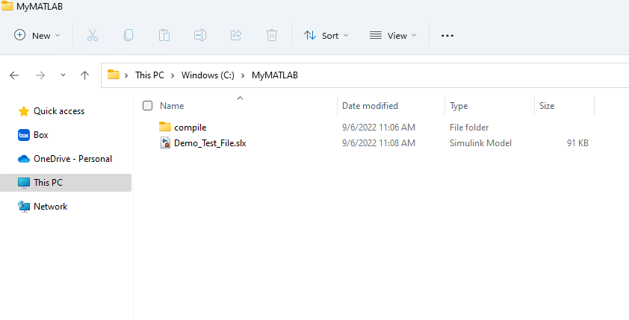
All your files can be organized in this folder.
- Specify to Simulink that it should put all the files used for code generation in the “Compile” folder.
  - Open Matlab 2022a. From the top Ribbon select “Preferences”, “Simulink”, “Open Simulink Preferences”, “General”. And specify the “Simulation cache folder” and the “Code generation folder” to be the Compile folder you created in the previous step.
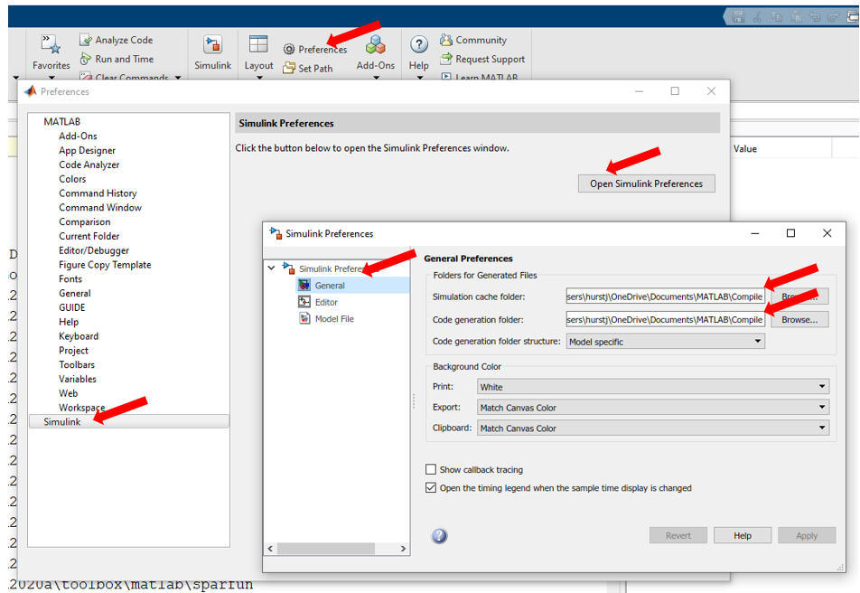
Now when Simulink needs to create extra files and folders (which it will do a lot) they will always be created in the same folder, and it will not make our MALAB folder littered with extra files we might not understand.
- Start MATLAB and navigate to this folder. Copy and paste the following command to the MATLAB command prompt:

setenv('ARDUINO_STATIC_LIB_PATH','C:\MyMATLAB')

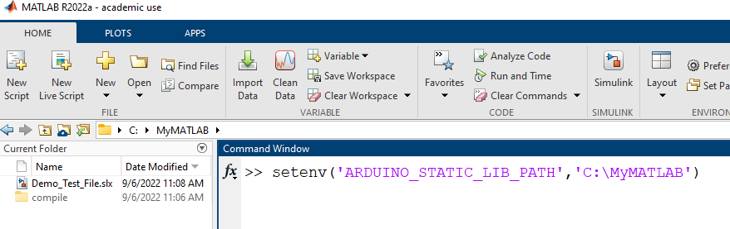
Please note you will need to run this command every time you start MATLAB

- Open your Simulink file and use “Monitor and Tune” to run your code.

Could not connect to target application: XCP serial port (system:2)

If the following error occurs (or similar ones):
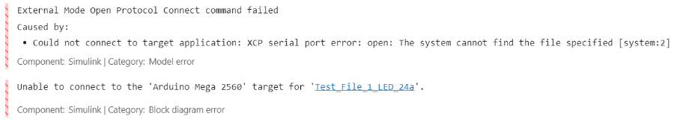
Try running disconnecting the USB cable and trying again. If that does not work, try manually specifying the COM port. This error happens if the file is set to AUTOMATIC for the serial com port. Unplugging and trying again updates the COM port settings. Alternatively you can manually specify the COM port to get rid of the error. Finally you can try select verbose setting: Go to “Hardware Settings”, “Hardware Implementation”, “Target Hardware Resources”, “External Mode”, click the box for “verbose”.

Could not connect to target application: XCP serial port timeout error on a MAC
Install 2024b. Go to “Hardware Settings”, “Hardware Implementation”, “Target Hardware Resources”, “External Mode”, Change “Polling Timeout” to 10 seconds. If that does not work try 15 seconds.

Could not connect to target application: XCP serial port (system:22)
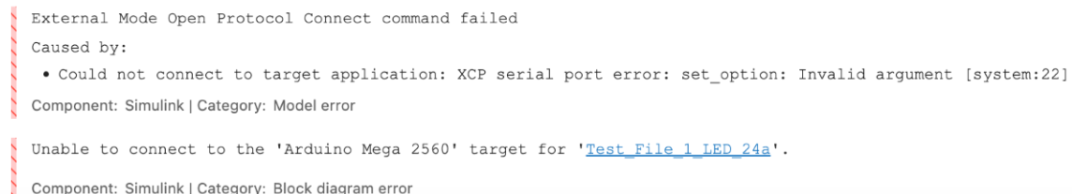
Go to “Hardware Settings”, “Hardware Implementation”, “Target Hardware Resources”, “External Mode”, make sure “Verbose” selected. If not then try making the data buffer “automatic” as well. And if it can’t be fixed then follow the above procedure for the timeout error on a mac: Install 2024b. Go to “Hardware Settings”, “Hardware Implementation”, “Target Hardware Resources”, “External Mode”, Change “Polling Timeout” to 10 seconds. If that does not work try 15 seconds.

Hardware Tab Does not Show Up

If the hardware tab does not show up:, Go to modeling tab, model settings, Hardware implementation, click the dropdown for the hardware board, select Arduino Mega 2560.
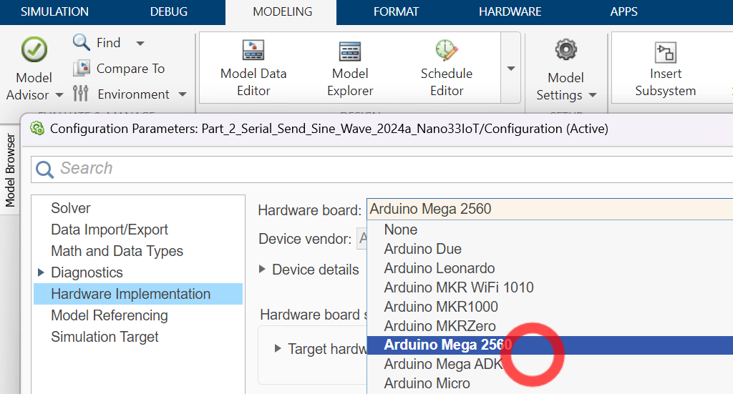

Permission denied or Can Not access error when compiling
Turn off any antivirus scanning software.

